Exhaustive Analysis of Indian Agriculture Sector Using Power BI

- Step for analysis removing unwanted columns using Power BI Desktop

Step 1. Download Power BI Desktop

Then this Interface will come

tep 2 . Click On The Blank Report

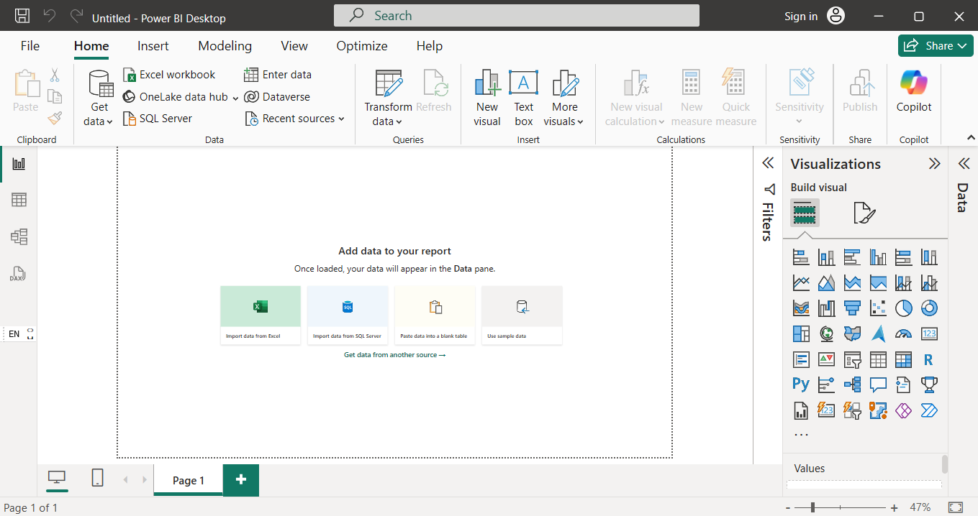

Step 3 . Then Upload Your File Just click on Get Data

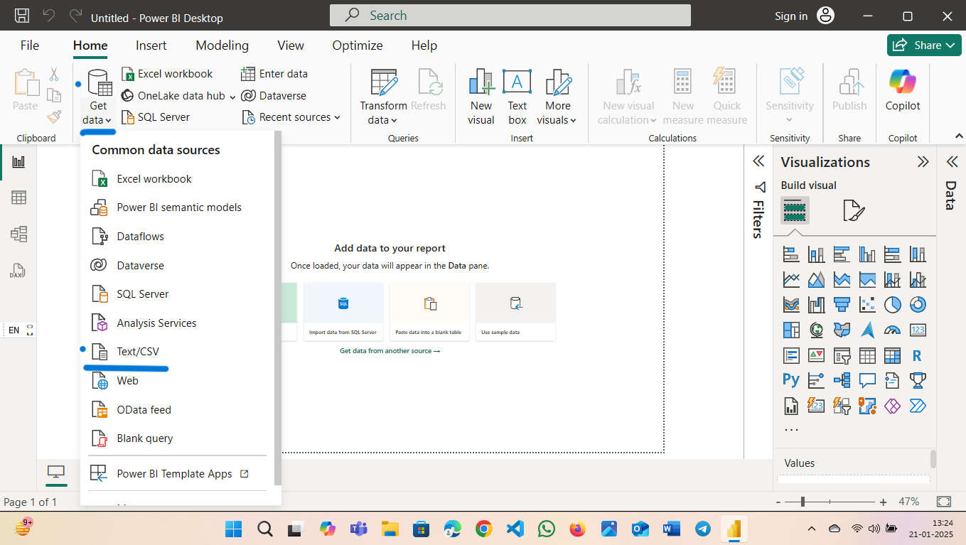

Step 4 . Then Select Your file

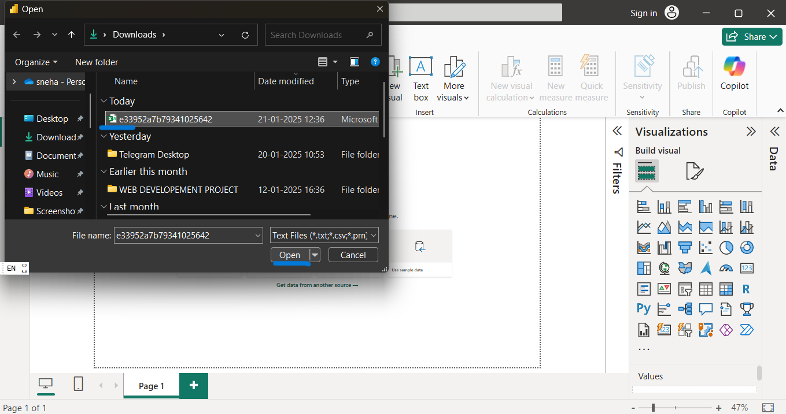

Step 5. Load Your File

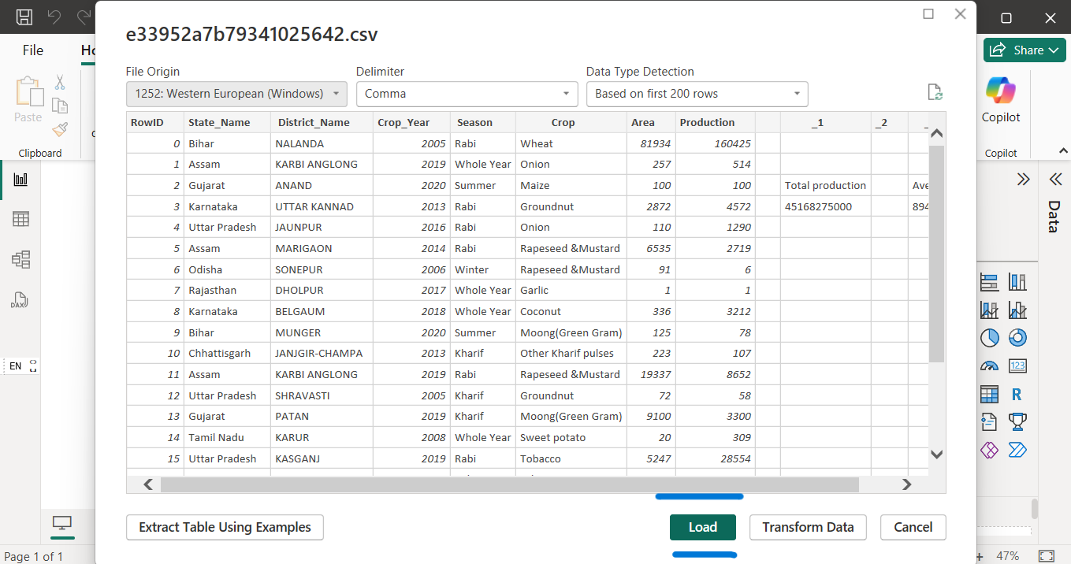

Step 6. Transform Data To make changes

Step 7 . Click Right 👉 to Title of Column and select remove

Step 8 . To undo the change In right there is applied step where you click on cross ➕ and Undo change

Step 9 . By click on view then click on quality

Step 10 . After make changes you Can save the file by click on File Close & Apply

